

Fincas de Ganuza 2008 Rioja Riserva

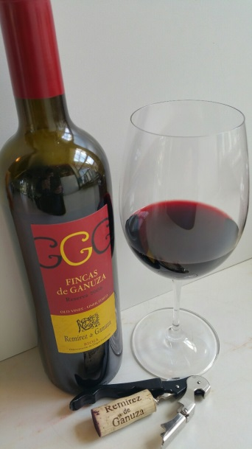Grapes: Tempranillo 90% & Graciano 10%

Alcohol : 14.5%

Oak : 24 months in French Oak 80% & 20% in American Oak

Tasting Note :

Dark Plum Robe with hint of rose around the edge,

Red currant and the morello cherry, touch of liquorice on the nose with hints

of mahogany.

Ripe currant fruit on the attack, lean rich fruit laden with cherry. Fresh fleshy

fruit, touch of grilled meat. Lovely, classic satin like finish with that hint of

mahogany on the tail.

Each autumn I make an offering from this wonderful Estate in Rioja. This is their second tier wine and I historically offer this wine as I find it matures more quickly than their Gran Reserva and the balance of fruit to oak is perfect, whereas the Gran Reserva is for me, too heavily oaked.

I receive a generous allocation of 100 cases of 6x75cl.

This is another fabulous wine that is drinking now and will further evolve over the next five years. This will cellar for a further decade. These wines are leaving Bordeaux behind in their wake !

50 cases 6x75cl £ 158.40 per case Inc VAT

(£ 109.00 per case Under Bond London)

Terms:

Offered subject to availability

Minimum order is 2 cases of 6x75cl

Payment on invoice please.

Delivery is free of charge in England. Deliveries to Scotland and Wales by separate negotiation.

1st October 2015